DBSE WEEK 5
Firstly download the spring tools and the workspace of it
Then Created a Spring Boot Project with Demo Spring
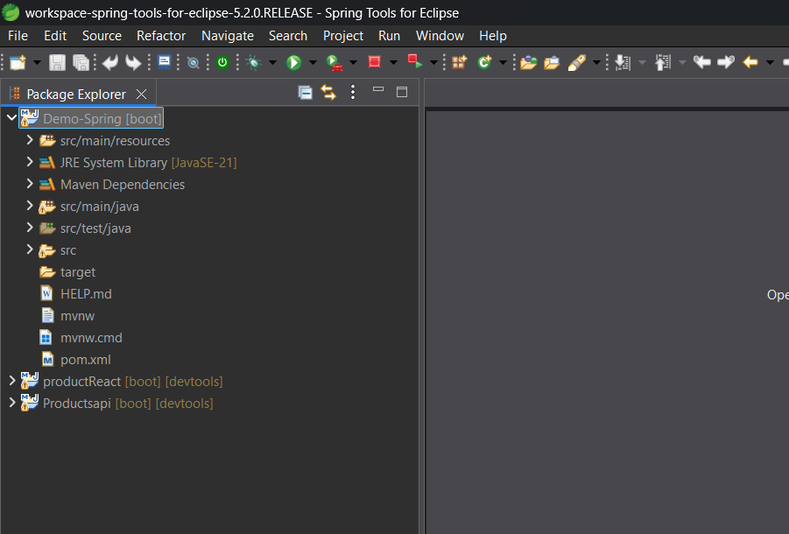
Added depend ices in this folder
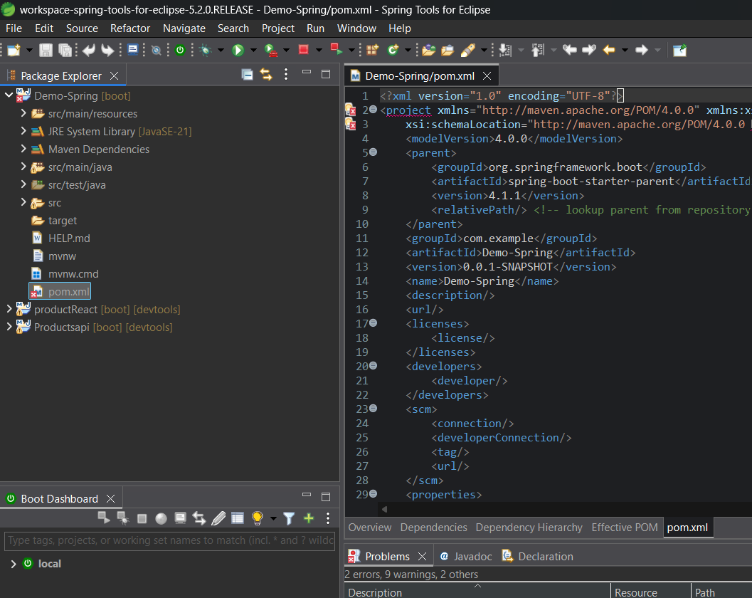
Created a Modal Class and Controllers and services
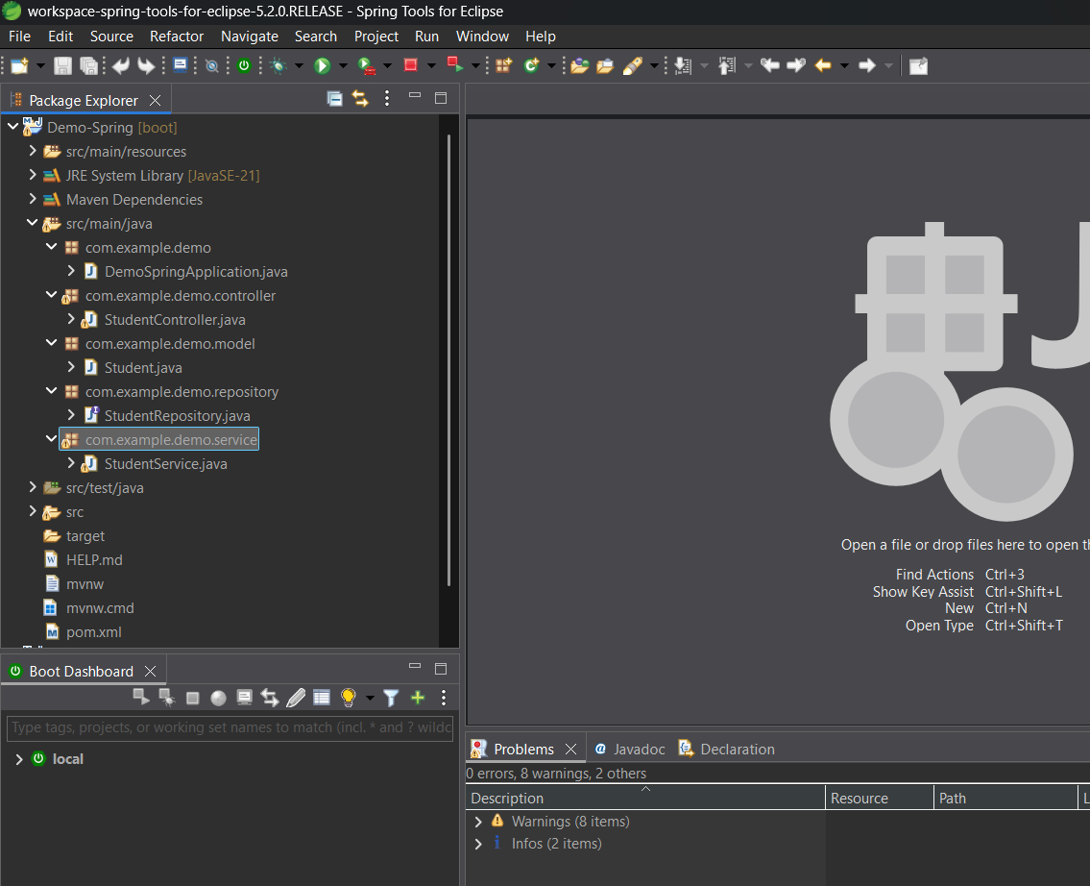
As we can see we created some packages along with their class and their respective codes
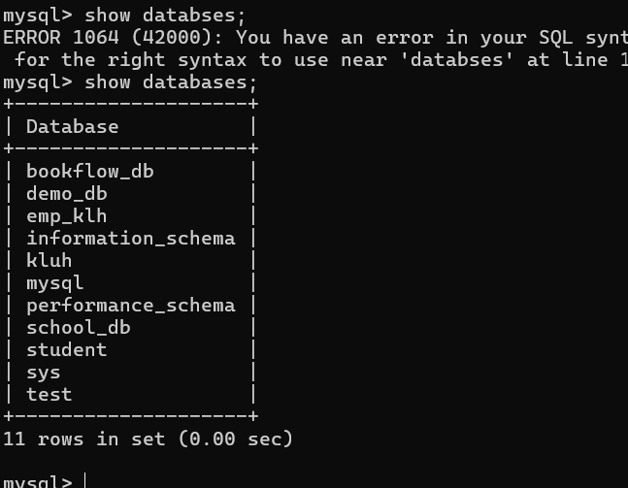
Created a databse called demo_db in mysql
After setting up all connections between them
we executed / run the application in spring tools then
Everything is working correctly. By console logs confirm that Tomcat successfully started on port 8080, connected to your MySQL database (demo_db), and automatically created the student table using Hibernate.
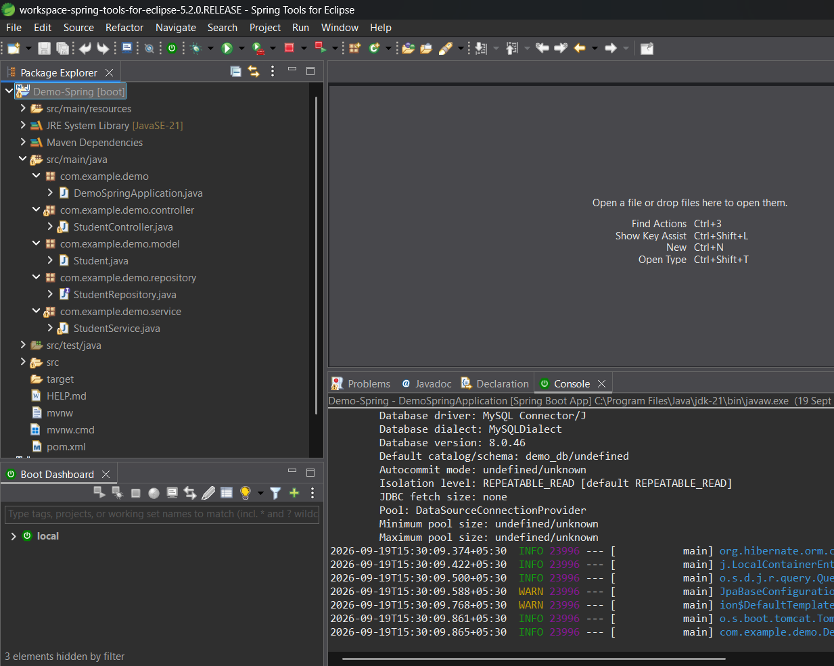
So later with the help of postman we can send the data into databse
